Date: 22-10-2026
CO-2 - AT-1
ANALYTICAL PROBLEM SOLVING
COURES CODE: DSA0308
COUSRE NAME: NLP

Reg no: 192425034 Name: K. Vinay

1. Morphological Analysis for Document Indexing
Aim
To decompose the words connected, connecting, and connection into their root and suffix components and normalize them for document retrieval.
Method and analysis
- Root identification: The common root of the given words is connect.
- Inflectional forms: The suffixes -ed and -ing represent different grammatical forms of the verb.
- Derivational form: The suffix -ion produces the noun connection from the verb connect.
- Word normalization: Each input word is mapped to connect to improve the matching of search terms.
Input word | Root | Suffix | Classification | Normalized form
connected | connect | -ed | Inflectional | connect
connecting | connect | -ing | Inflectional | connect
connection | connect | -ion | Derivational | connect

Code :
words = ["connected", "connecting", "connection"]
rules = {
"connected": ("connect", "-ed", "Inflectional"),
"connecting": ("connect", "-ing", "Inflectional"),
"connection": ("connect", "-ion", "Derivational")
}
print(f"{'Word':<15}{'Root':<12}{'Suffix':<10}{'Type':<15}{'Normalized'}")
print("-" * 65)
for word in words:
root, suffix, kind = rules[word]
print(f"{word:<15}{root:<12}{suffix:<10}{kind:<15}{root}")

Output:
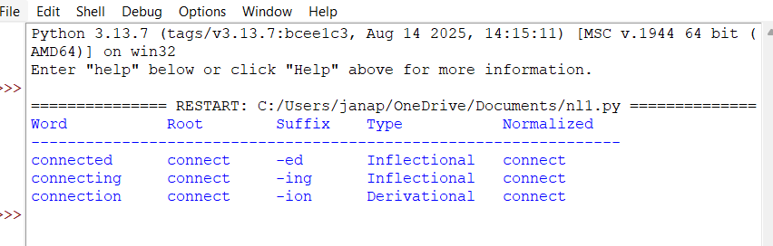

Interpretation:
The analysis shows that the three words share the root connect, although their suffixes and grammatical functions differ. By storing these words under a common normalized form, a document indexing system can improve search results and find relevant information even when different word forms appear in the documents.

2. Morphological Parsing for Sentiment Analysis
Aim
To examine the word structures of unhappy, happiness, and happily by recognizing their prefixes, suffixes, and base word and identifying the type of morphological change.
Method and analysis
- Base form: The common base word is happy.
- Prefix analysis: The prefix un- changes the meaning of happy to its negative form.
- Suffix analysis: The suffix -ness creates a noun, while -ly creates an adverb.
- Morphological classification: These word formations are derivational because they change meaning or grammatical category.
- Normalization: All three forms are associated with the base word happy.

Input word | Prefix | Suffix | Base form | Classification | Normalized root
unhappy | un- | None | happy | Derivational | happy
happiness | None | -ness | happy | Derivational | happy
happily | None | -ly | happy | Derivational | happy

The words happiness and happily involve a spelling adjustment in which y changes to i before the suffix is added.

Code :
words = ["unhappy", "happiness", "happily"]
rules = {
"unhappy": ("un-", "None", "happy", "Derivational"),
"happiness": ("None", "-ness", "happy", "Derivational"),
"happily": ("None", "-ly", "happy", "Derivational")
}
print(f"{'Word':<15}{'Prefix':<10}{'Suffix':<10}"
f"{'Base':<10}{'Type':<15}{'Normalized'}")
print("-" * 75)
for word in words:
prefix, suffix, base, kind = rules[word]
print(f"{word:<15}{prefix:<10}{suffix:<10}"
f"{base:<10}{kind:<15}{base}")

Output:
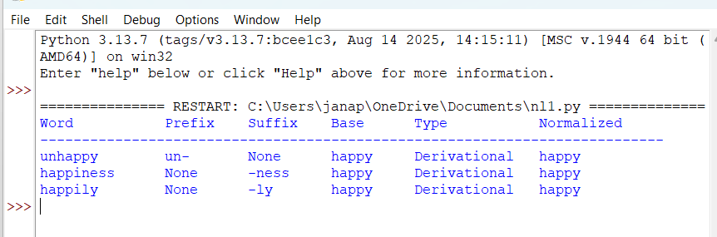

Interpretation:
The program recognizes the shared base word happy and groups its derived forms together. This is useful in sentiment analysis because related words can be processed consistently. However, the original form should also be retained, since unhappy expresses negative sentiment and cannot be interpreted as positive simply because its normalized root is happy.

3. Stemming-Based Preprocessing for a Search Engine
Aim
To process played, player, and playing by removing their suffixes, extracting their common stem, and preparing the words for efficient search engine indexing.
Method and analysis
- Inflectional suffixes: -ed and -ing represent grammatical variations of the verb.
- Derivational suffix: -er forms the noun player, meaning a person who plays.
- Common stem: play
Original word | Extracted stem | Removed affix | Transformation type | Normalized form
played | play | -ed | Inflectional | play
player | play | -er | Derivational | play
playing | play | -ing | Inflectional | play

Code :
words = ["played", "player", "playing"]
rules = {
"played": ("play", "-ed", "Inflectional"),
"player": ("play", "-er", "Derivational"),
"playing": ("play", "-ing", "Inflectional")
}
print(f"{'Word':<12}{'Stem':<10}{'Affix':<10}"
f"{'Type':<15}{'Normalized'}")
print("-" * 57)

for word in words:
stem, affix, kind = rules[word]
print(f"{word:<12}{stem:<10}{affix:<10}"
f"{kind:<15}{stem}")

Output:
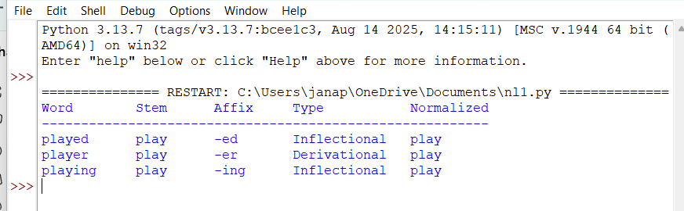

Interpretation:
The search engine indexes all three words under play. This improves retrieval when a user searches for a word but documents contain a different form. The player form is derivational, so a practical search system may retain the original word to distinguish people who play from the action of playing.

4. Finite-State Morphological Parsing
Aim
To build a finite-state parser for writes, writing, and written, handling regular and irregular verb forms and mapping them to the root write.
Method and state transitions
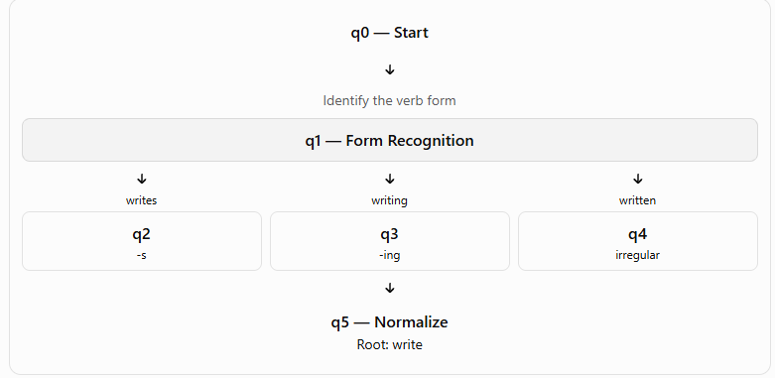
The writes and writing forms follow regular inflectional patterns. Written is an irregular past participle, so it requires a special mapping to write.

Word | Morphological breakdown | Classification | State path | Normalized form
writes | write + -s | Regular inflection | q0 → q1 → q2 → q5 | write
writing | write + -ing | Regular inflection | q0 → q1 → q3 → q5 | write
written | writ + -ten; irregular mapping to write | Irregular inflection | q0 → q1 → q4 → q5 | write

Code:
words = ["writes", "writing", "written"]
transitions = {
"writes": ("q2", "write + -s", "Regular inflection"),
"writing": ("q3", "write + -ing", "Regular inflection"),
"written": ("q4", "writ + -ten", "Irregular inflection")
}
print(f"{'Word':<12}{'State Path':<25}"
f"{'Breakdown':<22}{'Type':<22}{'Root'}")
print("-" * 100)
for word in words:
state, breakdown, kind = transitions[word]
path = f"q0 -> q1 -> {state} -> q5"
root = "write"
print(f"{word:<12}{path:<25}{breakdown:<22}"
f"{kind:<22}{root}")

Output:
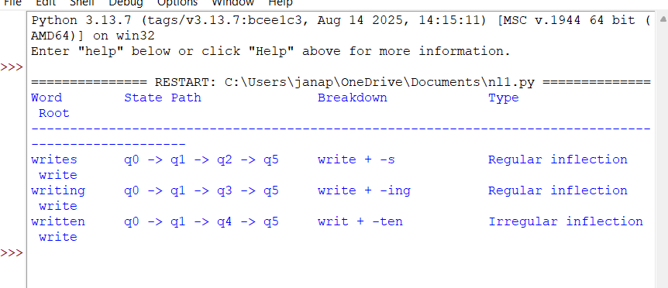
5. Porter Stemmer-Based Preprocessing for Document Retrieval
Aim :
To apply Porter stemming rules to relational, relation, and relate, showing the stemming steps and final normalized form.
Method and analysis
Porter stemming is a rule-based technique that reduces words by applying suffix transformations in a defined order. The algorithm checks specific conditions before replacing or deleting a suffix.
The main transformations illustrated here are:
- Step 2: Replace -ational with -ate when the rule conditions are satisfied.
- Step 2: Replace -ation with -ate when the rule conditions are satisfied.
- Step 5a: Remove a terminal e when the required conditions are met.
Original word | Step 2 result | Step 5a result | Final stem
relational | relate | relat | relat
relation | relate | relat | relat
relate | Not applicable | relat | relat
Step-by-step explanation
- relational → replace -ational with -ate → relate → remove final e → relat.
- relation → replace -ation with -ate → relate → remove final e → relat.
- relate → remove final e under Step 5a → relat.
Python program:

words = ["relational", "relation", "relate"]
def porter_stem(word):
steps = []
if word.endswith("ational"):
word = word[:-7] + "ate"
steps.append("Step 2: -ational -> -ate")
elif word.endswith("ation"):
word = word[:-5] + "ate"
steps.append("Step 2: -ation -> -ate")
if word.endswith("e") and len(word) > 4:
word = word[:-1]
steps.append("Step 5a: Remove final e")
return steps, word
print(f"{'Original':<15}{'Applied Rules':<42}{'Final Stem'}")
print("-" * 78)
for original in words:
steps, stem = porter_stem(original)
rule_text = "; ".join(steps) if steps else "No rule applied"
print(f"{original:<15}{rule_text:<42}{stem}")

Output:
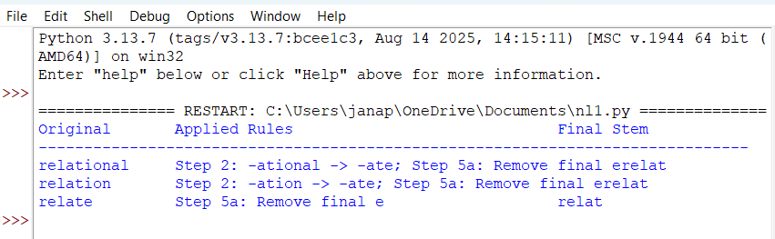

Interpretation:
The program illustrates how suffix replacement and removal can reduce related words to the common stem relate. This allows documents containing these forms to be grouped under a shared index term. The resulting stem is useful for retrieval, even though it is not necessarily a complete English word.
Note: The program is a simplified implementation of selected Porter-style rules rather than the complete Porter algorithm. For standard Porter stemming across a wider vocabulary, a library implementation such as NLTK's Porter Stemmer is recommended.

Conclusion :
This assignment demonstrates five approaches to morphological processing in Natural Language Processing. Rule-based morphological analysis identifies roots and suffixes, sentiment-oriented parsing preserves meaningful word relationships, and stemming helps normalize variations for search engines. Finite-state parsing demonstrates the handling of regular and irregular verb forms, while Porter-style stemming illustrates the removal of derivational suffixes.
The results show how different word forms can be mapped to common representations to support efficient indexing and retrieval. At the same time, preserving original words and semantic features is important when normalization may affect meaning or sentiment.

